

INFLO User Experience Evaluation & Future Plans

1600 International Drive

McLean, VA 22044

P: (571) 423-0200 F: (703) 880-0196

**www.octoconsulting.com**

INFLO UX Evaluation Plan Overview

Although a hackathon environment provides constraints around direct engagement with real users, many UX activities can still be applied to measure and optimize the user experience, as well as begin the planning of future activities to provide comprehensive evaluation and alignment of INFLO to user needs. The following evaluation plan details activities to convey what methods of evaluation have already been applied to INFLO, and which activities could be applied during future releases in order to deliver an elite user experience.

Table of Contents

**INFLO Evaluation Plan Overview2**

**Initial Discovery Methods3**

**Persona Development5**

Persona Creation Process5

INFLO Persona Development Worksheets6

INFLO Personas7

INFLO Workflows8

**Heuristic Evaluation9**

Heuristic Evaluation Overview9

Heuristic Evaluation Process10

INFLO Heuristic Evaluation11

**UX Testing Plan**1**9**

UX Testing Approach 19

UX Testing Creation Process22

INFLO UX Testing Plan23

INFLO UX Test Scripts24

INFLO UX Test Conclusions27

**Initial Discovery Methods**

Provided with a longer evaluation period, Octo would apply multiple methods of analysis to provide the broadest view in evaluating INFLO’s performance against user and business needs. To discover scope and initial user requirements, Octo engages early in the process to rapidly determine user needs, pain points, desired functionality and available content. Provided access to system analytics or Subject Matter Experts, Octo would also provide an in-depth analysis of past site usage and feedback from expert users.

Although not directly applicable to this instance of INFLO implementation, the above resources would provide a more complete and accurate picture of user performance on INFLO, potential future release features, and pain points being experienced by users, informing future iterations of the product and its broader implementation strategy.

Despite the limitations, a broad array of discovery methods were still available to shape INFLO and were applied early and iteratively to shape a product that was ultimately in line with both user needs and the release team’s vision. Below are sample questions typically asked in discovery engagements, and which were applied to shape INFLO from its inception.

**Project Vision**

* What is the vision for this offering?
* What defines success for this project?
* What are the potential pitfalls?

**Users**

* How many types of users will use this?
* Who is primary?
* Role(s)?
* Typical Background?
* Defining Attribute?
* Target user(s)?
* What problem do they have that the product solves?

**User Goals**

* What defines success for the user?
* What is a bad result? (If an experience doesn’t go well, what happens?)
* If users had a “magic wand” and could wish for anything to make the process better, what would they wish for?

**Competition/Other Options**

* What similar/current tools are in use today?
* Target audience? Value proposition?
* What are the relative strengths/weaknesses?
* How is this offering different?

**Process & Workflow**

* What is the nature of the user and their tasks/objectives?
* How do they prepare?
* Who do they work with?
* What tools do they use?
* How do they engage?
* What is the first step?
* And the next (and so on)?
* How does the engagement end?
* What frustrations/ pain points do they experience with their current process?

**Context of Use**

* What tools do the users use today?
* What data points do they collect today?
* What’s missing in the current process that this product will provide?

**Persona Development**

The goal of introducing and building personas is to define the mindset, desires, and daily tasks of system users. UX Analysts inform the persona creation process by conducting research, user interviews and surveys, which help reinforce the proposed personas. The three personas ultimately identified for INFLO were used as reference points to ensure that features were accessible and intuitive to the entire user base.

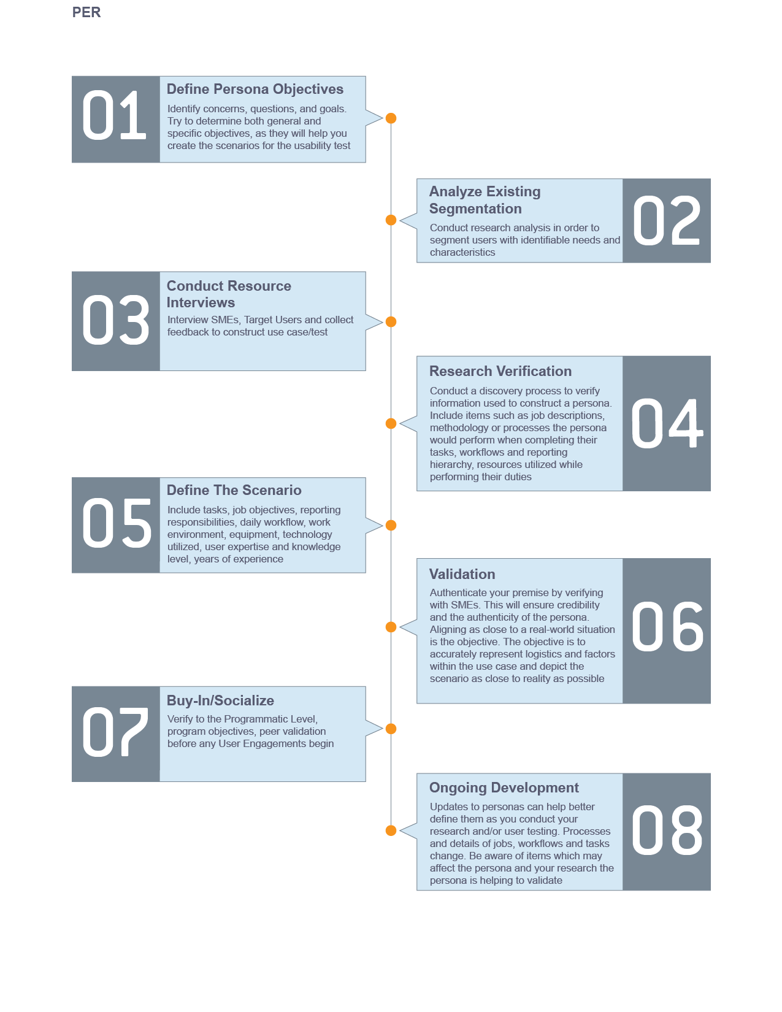**Persona Creation Process**

**INFLO Persona Development Worksheet Example**

|  |  |
| --- | --- |
| **Persona Development Worksheet** | |
| **1. Persona Title**  What kind of persona are you developing? Usually is a title or category | Home Buyer/Owner |
| **2. Specific Persona Details**  Give specific details to add personality to your persona. This isn’t always necessary but can add credibility to your research. | Beth is a 35 year old woman interested in buying a new home. She wants to make an informed decision about her purchase, including information about the surrounding area. Beth wants to purchase a home that is livable according to her criteria, as well as in an area that will provide a strong long-term investment |
| **Agency Researcher lowing evaluation methods can also be brought to bear to more fully surface user needs and3. Mission**  Give specific examples of the persona’s taskings, daily responsibilities, daily objectives, etc. Be as detailed as possible. Source job descriptions, interview real people who fit the profile and/or SMEs. | Beth wants to buy a home based on several criteria. Since she wants to live in a well-developed area, but also one that is environmentally safe.   * View travel safety information * View air & water quality information * View Demographic information |
| **4. Technology Skill Level**  This is an overview of the user’s skill level with the technology they use to complete their objectives, tasks and perform their job duties. | This user is very comfortable using web technologies, and has high bandwidth access, allowing for an unimpeded browsing experience. This user is likely to use either mobile or desktop devices to access the product. |
| **5. Tools**  This is a listing of the tools the persona uses daily to perform their job duties. | Internet Explorer, Google Chrome, Mozilla Firefox, Opera, Mobile, Tablet, Desktop |

**INFLO Personas**



**Heuristic Evaluation Overview**

Heuristic evaluation is an assessment method, which rates software applications and interfaces based on compliance with basic human factors principles of design. This is often the first stage of evaluation because it can be completed rapidly, and with only a few UX analysts. For any evaluation, Initial concerns and the specific focus of the assessment should be identified. Determining specific instances of adherence to, or exceptions against existing standards greatly aids in the focusing of subsequent evaluation efforts, including UX Testing. In the following documentation of the first heuristic review of INFLO, exceptions identified during this review became the foundation for future testing.

**Heuristic Evaluation Criteria Categories:**

* Perceiving and Evaluating the System
* Developing and Executing Action Sequences
* Context and Relations
* Specific Interface and System Issues

**Heuristic Evaluation Process**

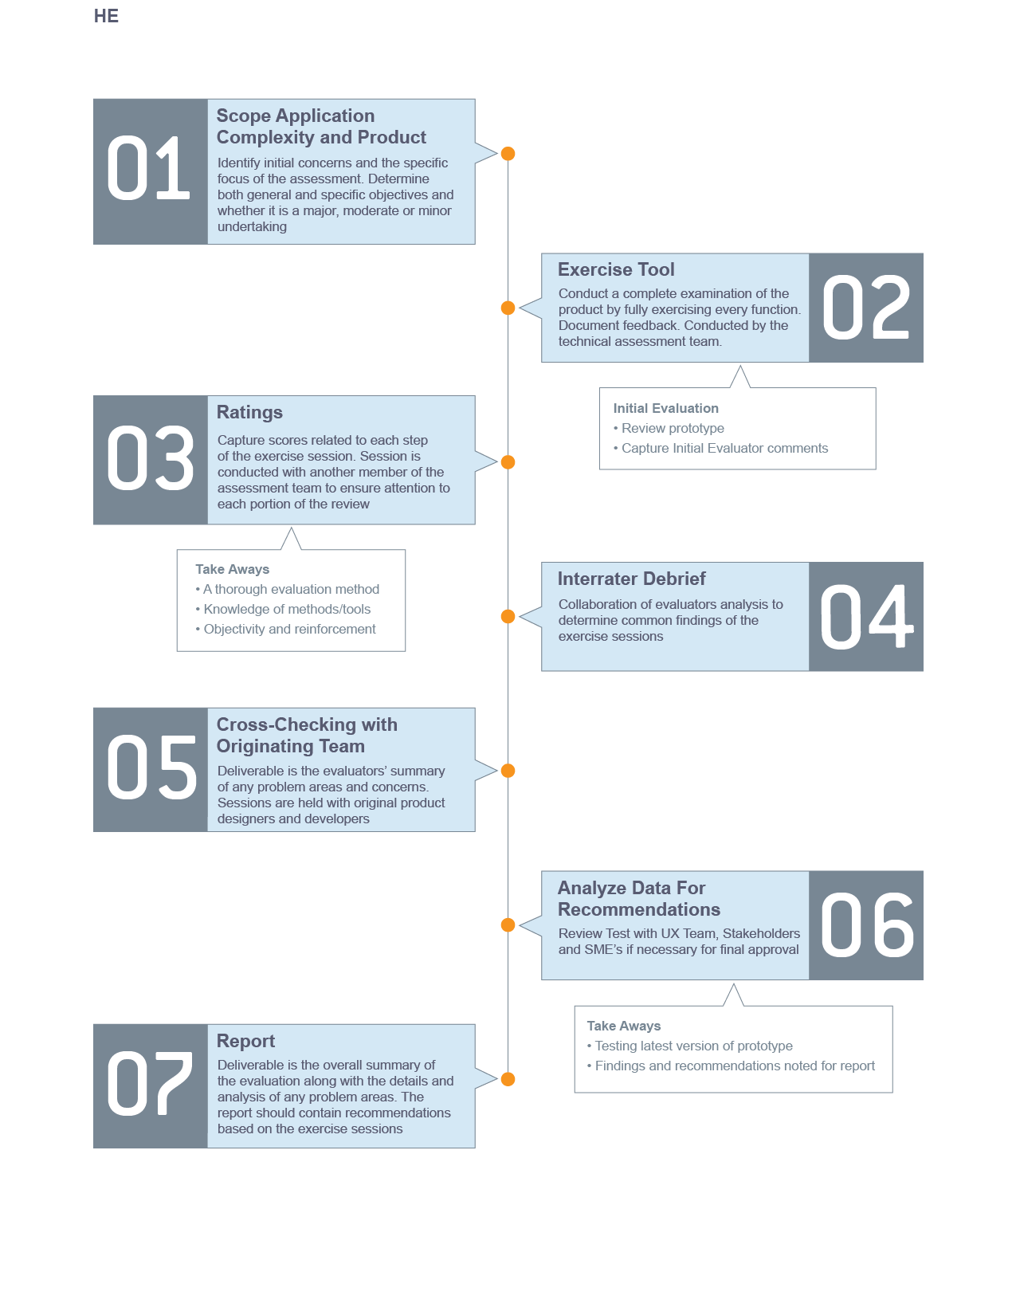

**Heuristic Review of the “INFLO” Web Application**

**Summary**

The Second Mockathon UX team was tasked to perform an evaluation of the “INFLO” website on 21 March 2015. This report summarizes the high level findings of this evaluation.

Two primary concerns were exposed. Complicated language was used throughout the application that would confuse the user and discourage use. A lack of simplified instruction was not available creating a unclear landing page. Detailed descriptions of all usability issues exposed during this evaluation are included in the following sections.

**Assessment Method**

Heuristic evaluation is an assessment method which rates software applications and interfaces based on compliance with basic human factors principles of design. For this evaluation, four areas were considered.

1. Perceiving and Evaluating the System
2. Developing and Executing Action Sequences
3. Context and Relations
4. Specific Interface and System Issue

**Overall Impressions**

From the INFLO homepage, users can easily search for a county to view comparative data from. However no information on what data will be retrieved is available. There is no example data available and no description of the pages purpose. The page focus should be set on the input box on page load.

The INFLO dashboard shows the county and associated state that was searched for. It gives an overall score that is not self-explanatory. The score percentage should be in comparison to all other counties to show context. Four tiles showing Water Quality, Air Quality, People, and Travel Safety are showing county data. This data does not provide context and displays a percentage that is not associated with a positive or negative result. Results should show percentages lower or higher than all counties data.

**Heuristic Review Round 1**

**INFLO Home Screen (Wireframe):**

* Logo centered at top (alt text for logo image)
* Search centered under logo (alt text for search button if image used)
* Search includes example input “Fairfax, VA”
* Focus is on search on page load
* Tagline below search box
  + “How much do you know about where you live?”
* Search informative infographic
  + “Search for a County” “View the Score” “Explore the Details”
  + Three screenshots showing steps. (alt text explaining images)
  + Arrows showing flow. (alt text “Arrow pointing right”)

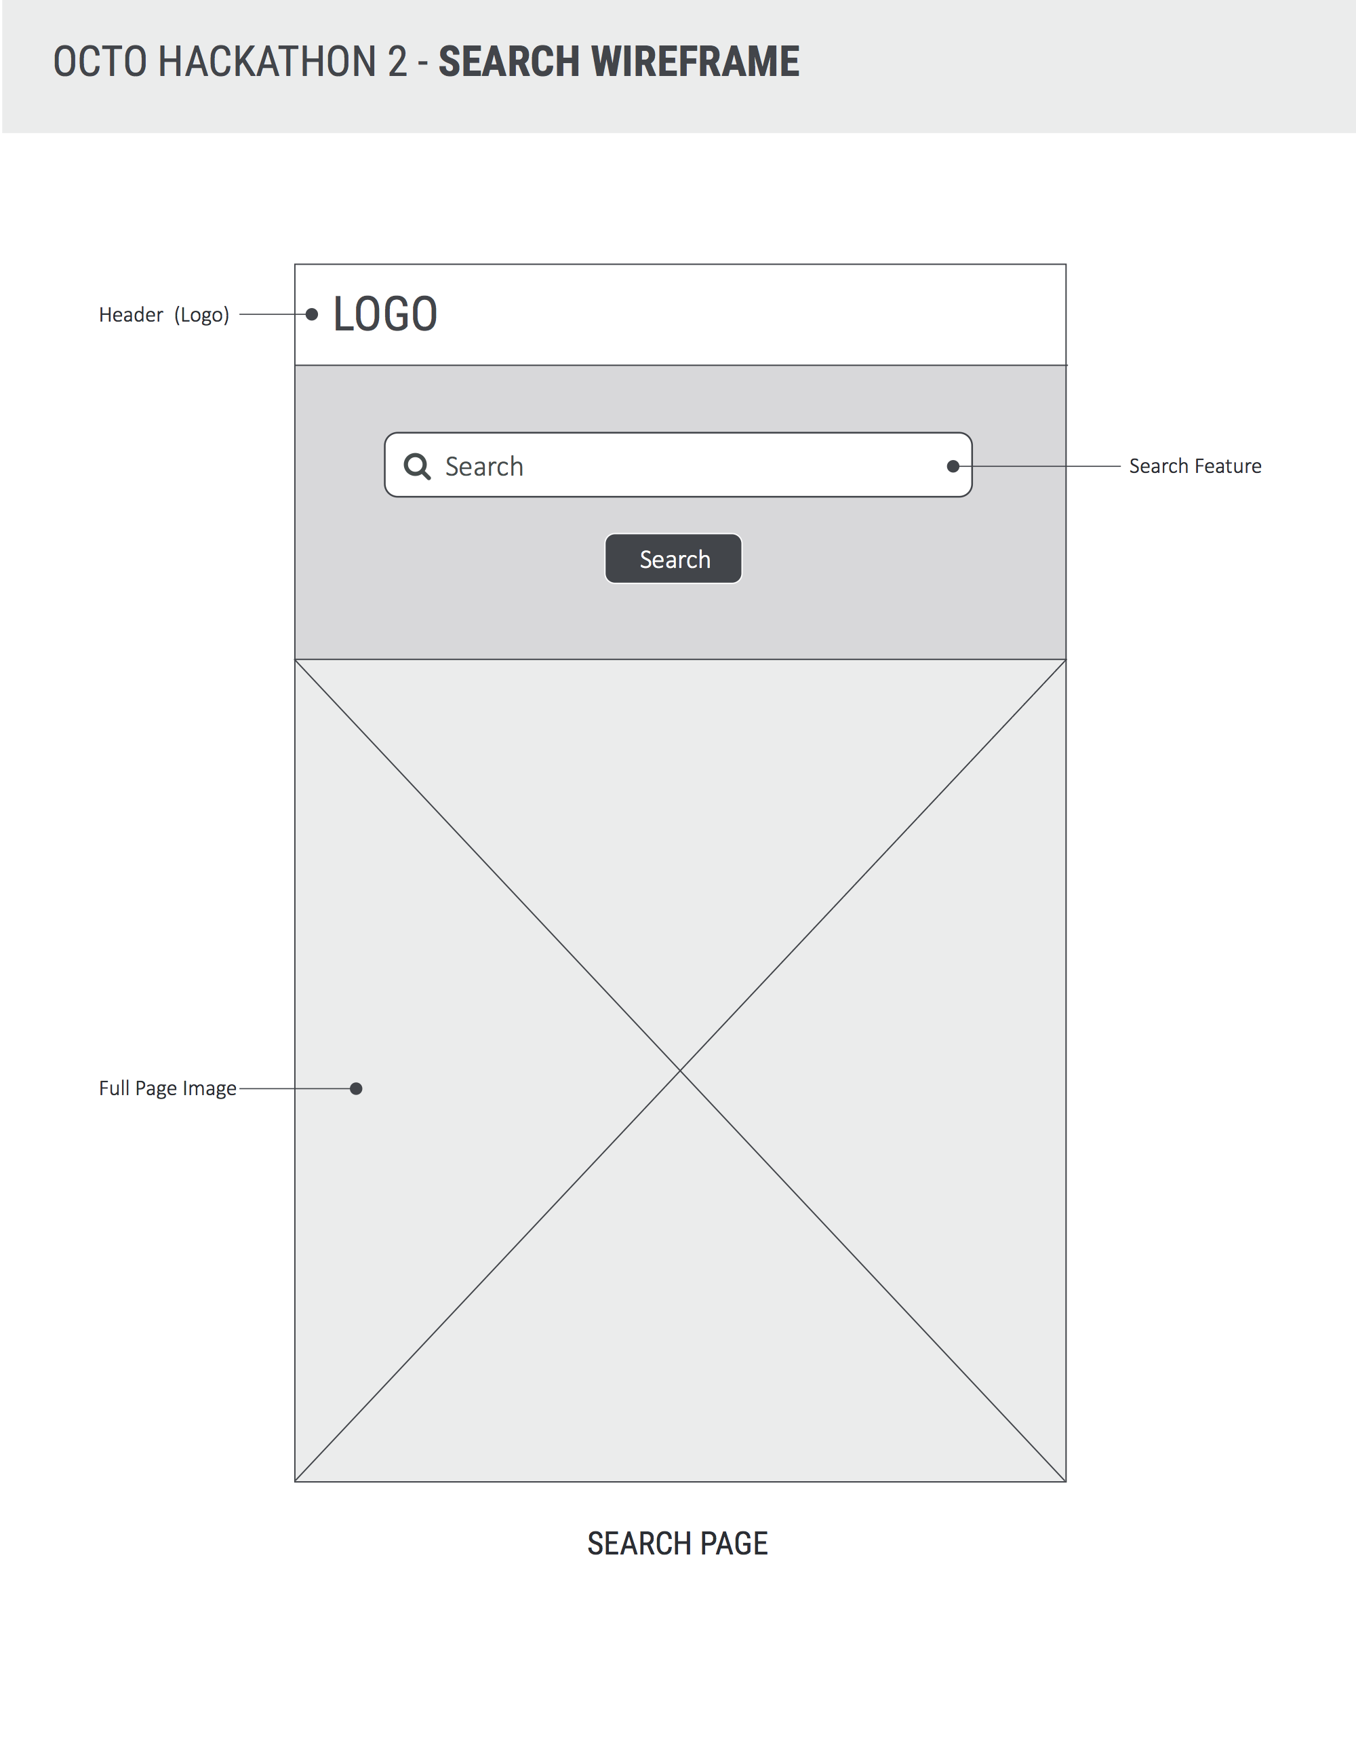

**INFLO Dashboard Screen (Wireframe):**

* Logo centered at top (alt text for logo image; link back to home page)
* Search centered under logo (alt text for search button if image used)
* Search includes example input “Fairfax, VA”
* Focus is on search on page load
* Tagline below search box
  + “How much do you now about where you live?”
* County name and associated state is shown under search.
  + County name is larger than state showing data is pertaining to county only.
  + Large score is shown on right with percentage.
* Four tiles are displayed below county name and score
  + “People”, “Travel Safety”, “Air Quality”, “Water Quality”

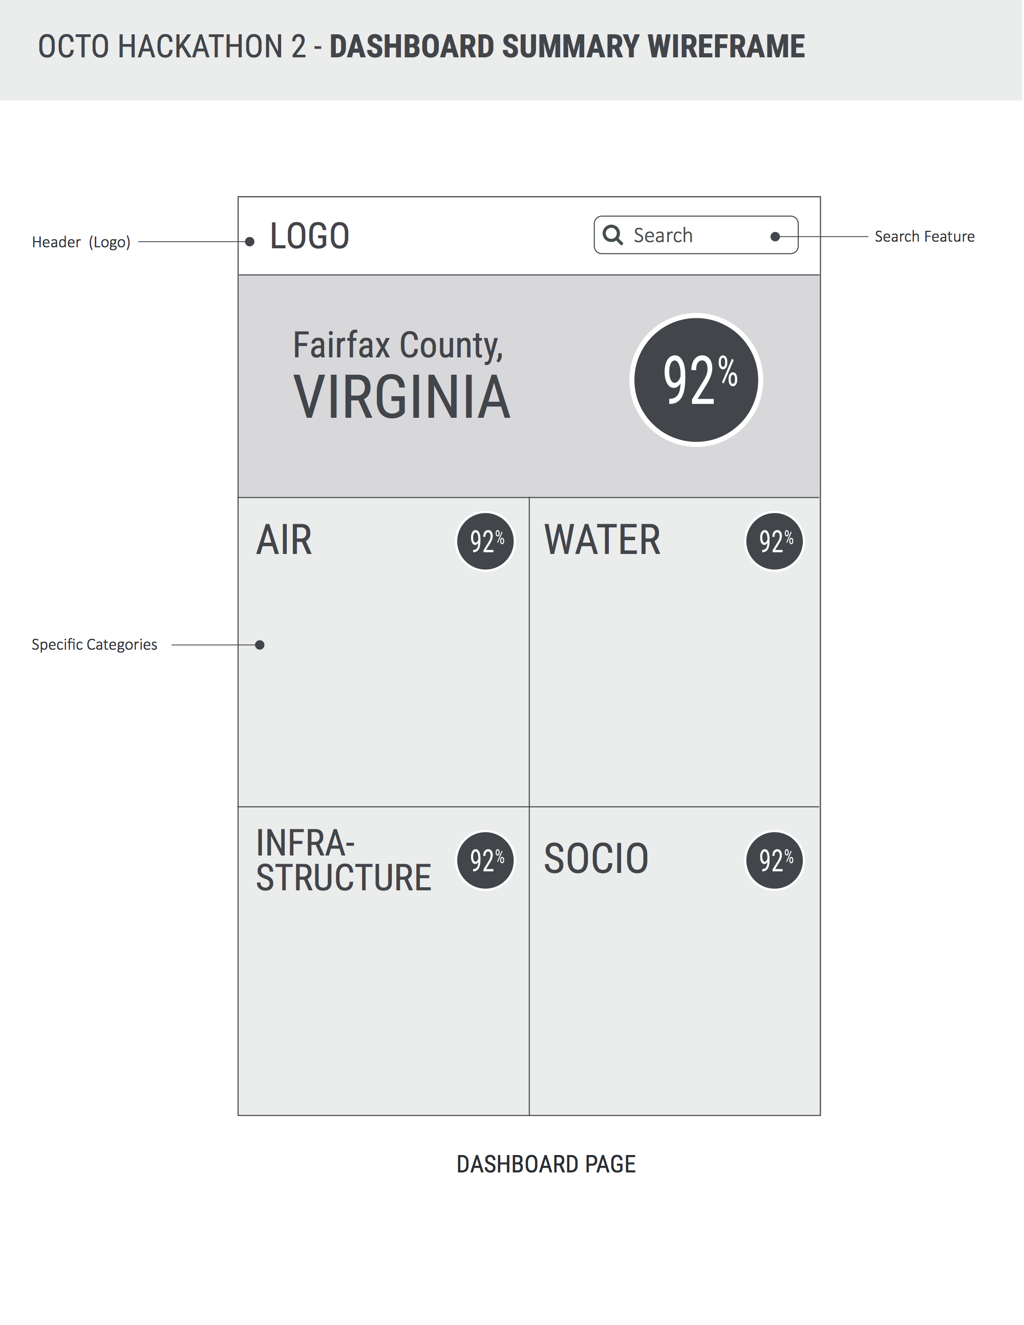**INFLO Tiles (Wireframe):**

* “People”, “Travel Safety”, “Air Quality”, “Water Quality”
  + People
    - Median Income
    - Percentage of Unemployed
    - Rate of Violent Crime
  + Travel Safety
    - Highway Roads
    - Streets
    - Traffic Fatality
  + Air Quality
    - Nitrogen Dioxide (NO2)
    - Sulfur Dioxide (SO2)
    - Carbon Monoxide (NO2)
  + Water Quality
    - Percentage of county drought
    - Percentage of Mercury
    - Percentage of Arsenic
* *Show more info about data point on select?*
* *Small text “Levels based on blab bla bla Data source”?*

**Any percentage under 50% will display as the difference from the mean.**

**30% Higher = 70% Lower**

**Conclusion**

A simple and informative search is necessary for an effective user experience. Clear direction and understandable terminology is needed. Accessibility should always be considered to allow for a diverse base of users.

Data should be presented in a way that is obvious to the user. All data points should relate to the county searched as well as it’s place among other counties.

**Modifications Made**

Design was improved to show Logo, Search, and Tagline on top center and remains throughout the app home page as well as dashboard.

Search button was incorporated into search box.

Search infographic showing a three-step process was added to home screen.

Tile names were updated to “People”, “Travel Safety”, “Air Quality”, “Water Quality”.

Data Sources were added to tiles.

**Heuristic Review Round 2**

1. Search Text
   * Search should not be Cap sensitive and spaces between county and state code should not be used to determine search results.
2. Infographic
   * Graphics should not include rasterized text.
   * Graphic size should be decreased to include smaller resolutions and reduce complexity
   * Alt text is needed for accessibility
3. Search Icon/Button
   * Alt text is needed for accessibility

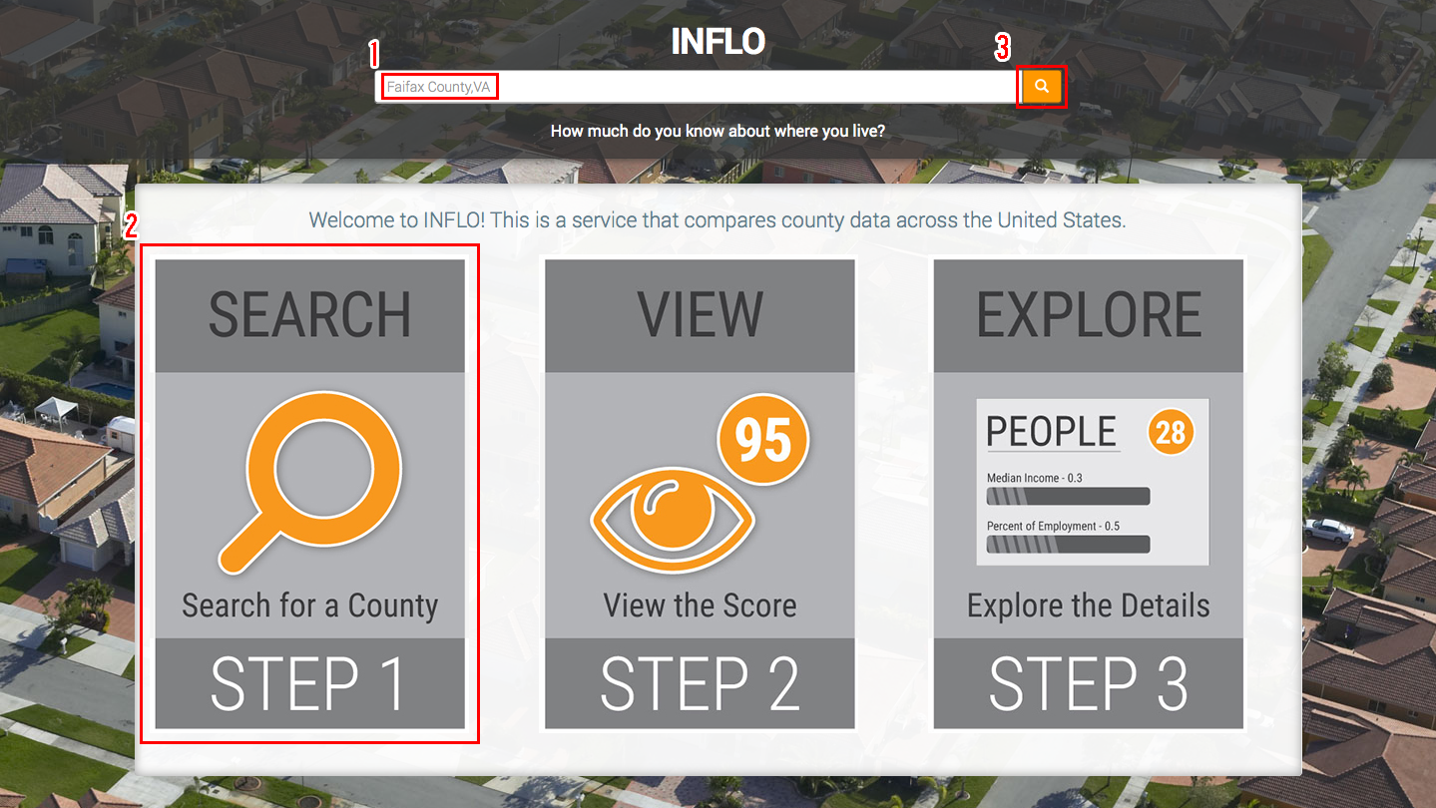

**INFLO Dashboard Screen**

1. INFLO Score

* Score number should show context (Bad, Average, Good)
* Color orange association may prove confusing to user

1. Tile Score

* Score number should show context (Bad, Average, Good)
* Grey box distracts from header

1. Data Points

* Data points should show exact units (ppb, ppm, $0.00)
* Data points should not be separated by a dash
* Progress bar should not be animated

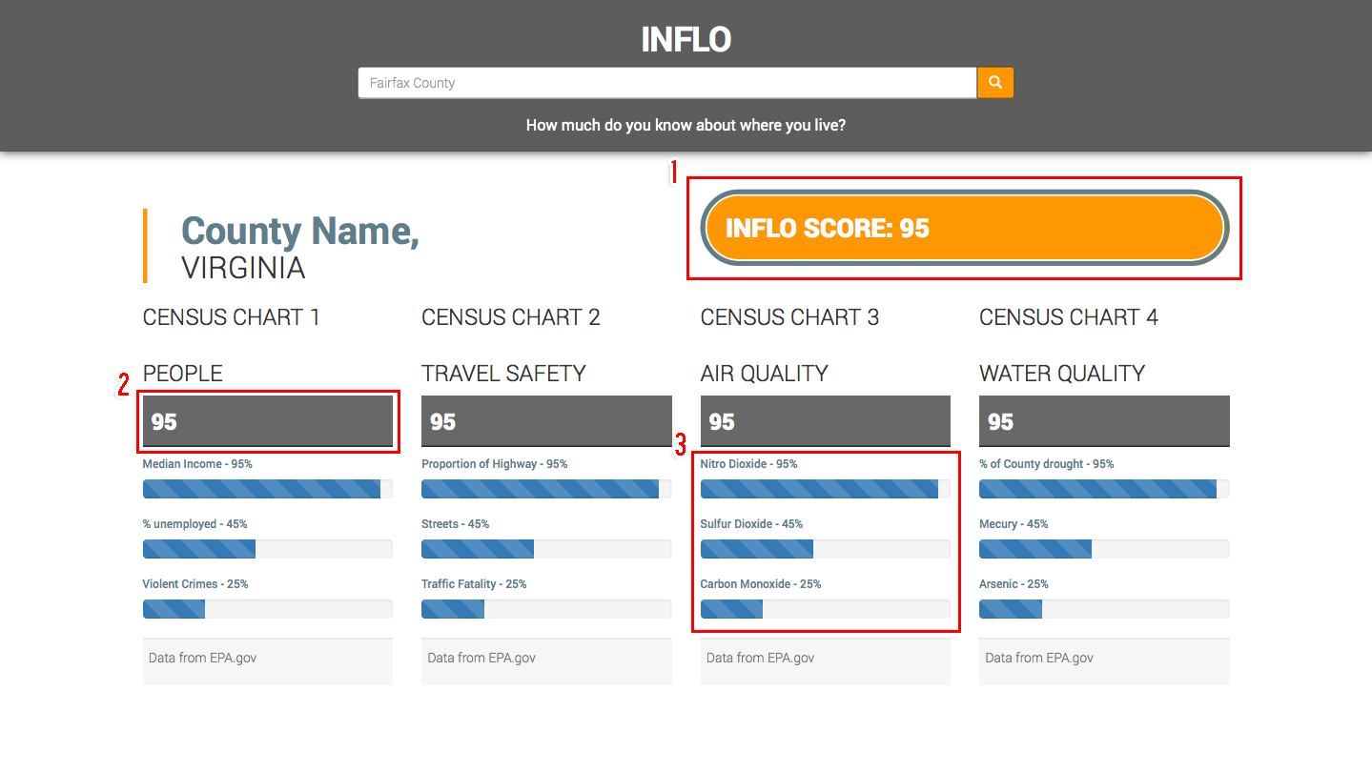

**INFLO Dashboard Screen Mobile View:**

* Tile content separation becomes difficult to see when viewed in mobile
* Error message text is not obvious to the user.
  + “No results found. Please check your spelling and try again.”

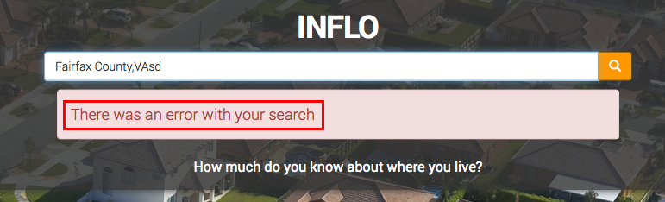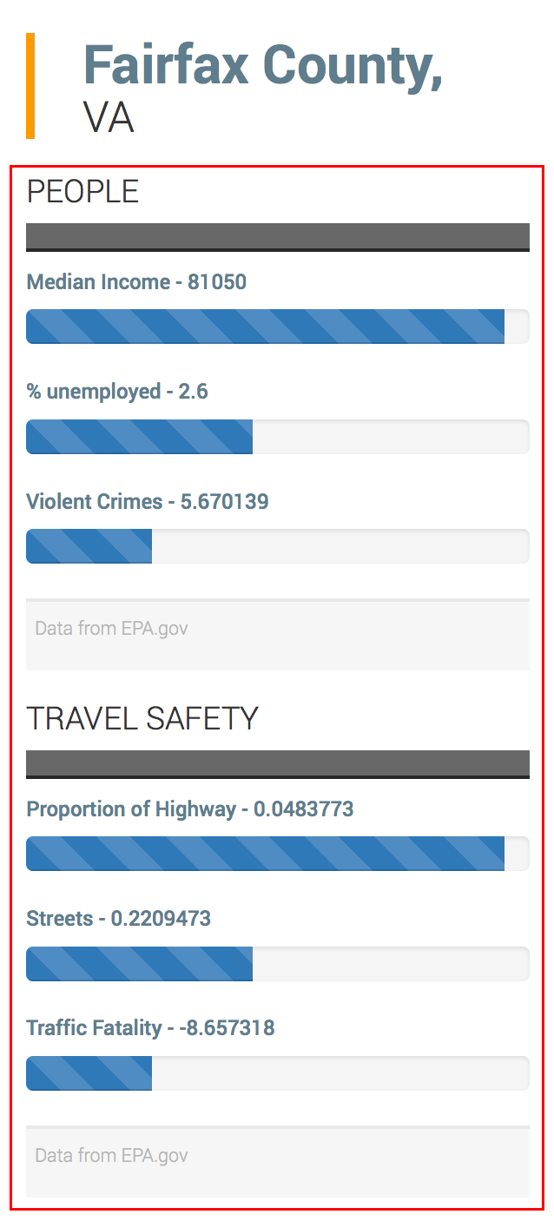

**Conclusion**

Searching for counties is the main user interaction and should be as simplistic as possible. Autocomplete as well as mistype leniency should be implemented to prevent errors. The user should also have access to a simple “Steps” example that gives an overview at a glance of what the application can be used for. No text should be raster as it will not be available for screen readers.

The dashboard should show easily identifiable ratings and provide understandable data points. All graphics and scores should have context and meaning to the user. Careful consideration regarding colors should be made when highlighting scores as to not display conflicting meanings.

The responsive mobile view tile data becomes difficult to separate when viewed on smaller devices. A more visible title or separator is needed.

**UX Testing Approach**

**UX Testing Overview**

Octo User Experience Architects design and conduct multi-faceted usability tests with the goal of informing product design and eliminating usability problems and frustrations during agile development cycles. Findings of usability testing can serve as benchmarks against which to judge the usability of future versions of digital products.

**Determine UX Focus Points**

* Predictability
* Consistency
* Familiarity
* Learnability
* Responsiveness

**Be Specific with Test Objectives**

Test objectives must be specific: “We want to see if the product is easy to use” is too general. To formulate test objectives, think about:

* Identifying where complex interactions break down
* Whether terminology matches the user’s vocabulary
* Whether some personas may have specific hurdles
* Concerns of the product owners
* Problems raised by designers/developers

**Develop Test Scenarios**

The user must be able to define a discernable path to complete common and critical functionality. The interface should be designed to provide environmental support to the user’s efforts. This means that the interface should help facilitate task performance and to minimize hindrances, distractions, and potential errors. Design test scenarios that promote the efficient application of the below properties.

**Factors contributing to this dimension include:**

* Sequential Clarity
* Simplicity
* Traceability
* Forgiveness/Recoverability
* User Control

**Recruit Participants**

To provide a representative cross-section of users, recruit from every touch-point possible. This includes target user groups, SMEs, and users with diverse skill sets. Consider a variety of participants drawn from a range of user personas who fit into the overall user group to provide full coverage of the range of interactions that the user base might display.

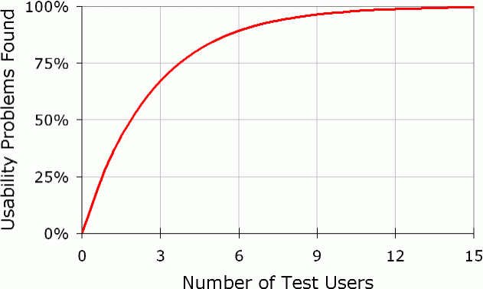**Testing Sessions**

**5x5x5 Testing**

Octo uses a 5x5x5 format to conduct user testing, in which around 5 users complete testing on the initial design iteration, with 5 users testing each subsequent design iteration that incorporates revisions from previous testing. This format of usability testing is an industry best practice, which reveals the vast majority of potential usability issues, while enabling organizations to conduct testing with limited user pools.

**Documenting and Tracking Actions**

Usability testing enables the gathering of information from people who use a product. For best results, use participants who have never seen the product before – and ask them to perform a series of tasks. It is critical not to tell the users how to perform the specific tasks because you want to observe them, take notes, and get their feedback.

**Collecting Feedback**

Comments from participants actively using the product can give an incredible depth of information on the product. Constructive user feedback can be obtained individually or from a group of users. When working with individuals, being able to see the users’ body language and facial expressions provides as much or more value than simple binary pass/fail information. Were they frustrated? Did they seem confused? Were they comfortable moving from one screen to the next while using the product?

Ask participants to share what they are thinking out loud. Learning their thought process as they work to complete a task will provide insights on ways to make that task simpler or more streamlined once testing is complete.

**In-Process Change Recommendations**

Summarize the data analysis and offer recommendations and solutions as drawn from the latest testing data throughout the development cycle. Include industry best practices as guidelines when possible. Ensure that these changes are implemented into the next iteration of the product to allow for both incremental development and measurement of improvement or detriment of newly added interface or product features

**UX Testing Process**

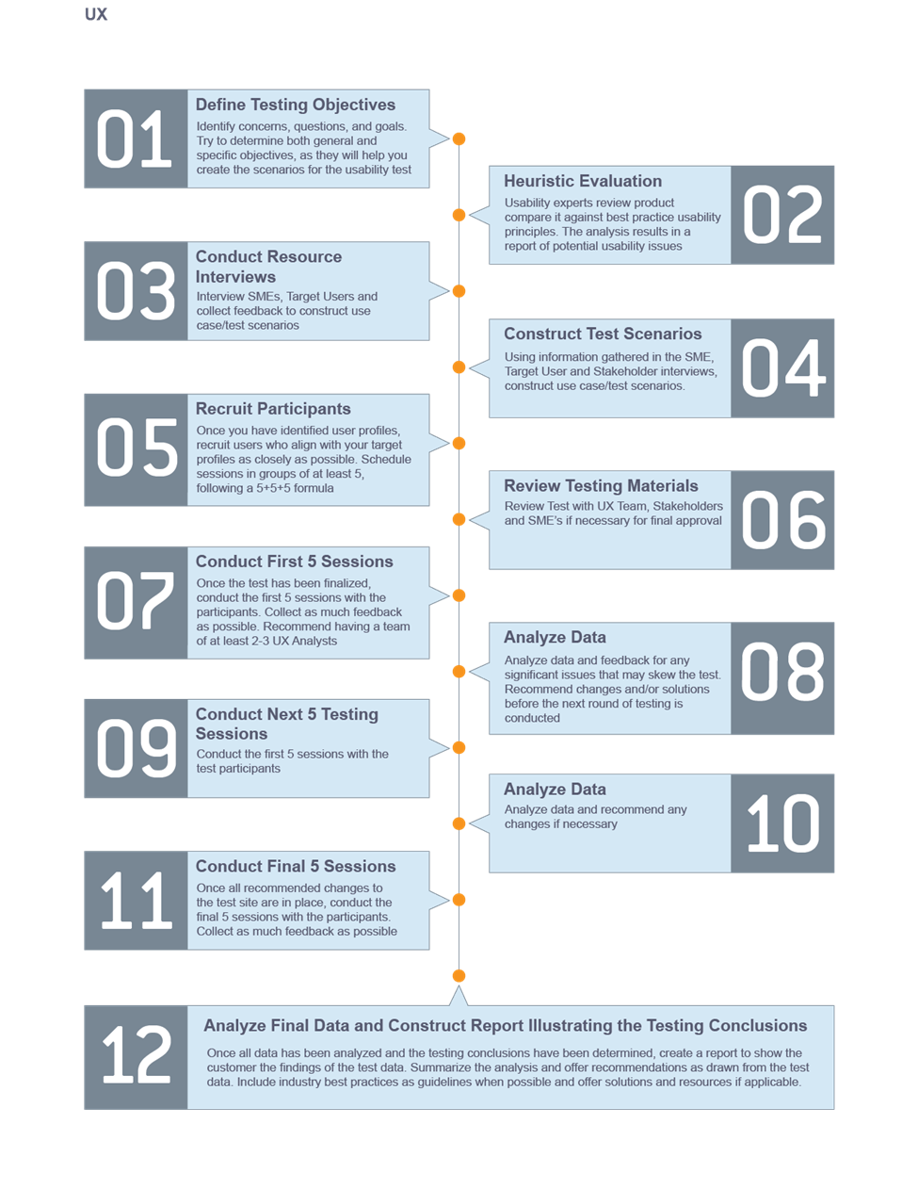

**INFLO UX Testing Plan**

With limited access to a large bank of users, the INFLO UX team turned to facilitators who weren’t actively involved in the development of INFLO, and asked them to assume the roles of the established personas and follow set scenarios to complete tasks using INFLO. The supporting testing documents, including scenarios and scripts are included below. Although the sample size was limited to three during this testing engagement, testing resulted in rich data collection on both quantitative preference metrics qualitative comments that provided insights into the most impactful areas to direct focus on iteration and redesign.

The System Usability Scale was also employed for this test in order to measure quantitative metrics around user preference for the system and begin to diagnose which areas of the site were most critical for improvement.

**Usability Task 1 (Agency Researcher):**

**Scenario:** As a researcher working for EPA, you are tasked with collecting the county INFLO score, collecting overall air and water quality data from both Fairfax, and Fauquier counties in Virginia. In addition, you need to collect metrics on Nitro Dioxide and Mercury concentration.

Information to gather from each County: INFLO score, overall air and water scores, ratings for presence of Nitro Dioxide and Mercury.

**Usability Task 2 (Home Buyer):**

**Scenario:** As a prospective homebuyer in a new area, you want to find out more information about the surrounding counties and their quality of life. To identify this information, Search for two counties and gather the INFLO score, overall Travel Safety, and People scores, and Race and Age composition.

Information gathered from each County: INFLO score, overall Travel Safety, and People Scores, Age and Race composition.

**INFLO Home Buyer/Owner Persona Test Script**

|  |  |  |  |
| --- | --- | --- | --- |
| **Question 01** | **Expected Responses** | **Rating**  **2 = Pass**  **1 = Difficulty**  **0 = Fail** | **Time on Task** |
| **1. Start Home Page**  As a prospective homebuyer in a new area, you want to find out more information about the surrounding counties and their quality of life. To identify this information, Search for two counties and gather the INFLO score, overall Travel Safety, and People scores, and Race and Age composition. | Begin typing on page load or select search box and begin typing.  Locate and view overall rating.  Locate and view overall Travel Safety, People Scores  Locate and view Race and Age data  Locate Traffic Fatality data | 2 : 1 : 0  2 : 1 : 0  2 : 1 : 0  2 : 1 : 0  2 : 1 : 0 | **Time:** Record time on task and any task-related comments here. |
| **2. Specific Activities**  **A.** Search for a county  **B.** Find the county overall rating, and Travel Safety, and chemical ratings for Fairfax County, VA  **C.** Find the county overall rating, and air, water, and chemical ratings for Fauquier County, VA |
| **3. Notes**  Use this section to record notes. | | | |

**INFLO Agency Researcher Persona Test Script**

|  |  |  |  |
| --- | --- | --- | --- |
| **Question 02** | **Expected Responses** | **Rating**  **2 = Pass**  **1 = Difficulty**  **0 = Fail** | **Time on Task** |
| **1. Start at Home Page**  As a researcher working for EPA, you are tasked with collecting the county INFLO score, collecting overall air and water quality data from both Fairfax, and Fauquier counties in Virginia. In addition, you need to collect metrics on Nitro Dioxide and Mercury concentration. | Select search box and begin typing. Execute Search  Locate and view overall rating.  Locate and view overall ratings for Water and Air subcategory  Locate and view data points for Nitro Dioxide and Mercury | 2 : 1 : 0  2 : 1 : 0  2 : 1 : 0  2 : 1 : 0 | **Time:** Record time on task and any task-related comments here. |
| **2. Specific Activities**  **A.** Search for a county  **B.** Find the county overall rating, and air, water, and chemical ratings for Fairfax County, VA  **C.** Find the county overall rating, and air, water, and chemical ratings for Fauquier County, VA |
| **3. Notes**  Use this section to record notes. | | | |

**INFLO UX Test Conclusions**

User testing was completed with a limited sample. Application navigation was overall successful with all three users able to complete the activities given with little trouble. However, although users able to easily find and read results, they weren’t easily understood or interpreted due to a lack of context about the overall categories, or unfamiliar units. Despite these limitations, an average SUS score of 85 demonstrated a strong user preference for INFLO, rating in the 90th percentile of all SUS responses, signaling a strong indication of user comfort with INFLO.

**Problems and Modifications**

* “Enter should trigger search”
  + Loading animation will replace search button on search
* “Values have no meaning…”
  + Additional help text will be valuable and should be available through help icons next to data points
* “Backing looks like neighborhood so mentally I think this provides information about neighborhood”
  + Image will auto update after a set amount of time and vary between page loads
* “Color text for rating snapshots would help the ‘at a glance’ understanding of the data
  + Good, average, and bad will be color coded with common ratings colors green, yellow and red
* “My Eyes were drawn to the infographic and I expected to be able to click it”
  + Infographic will be redesigned to show a small icon with description text explaining the steps
* “A little slow. No loading was indicated”
  + Loading animation will replace search button on search